**Design Document (Scrapbook Style) - Go**

Go Design Document:

**Introduction:**

For Go the paradigm used is Functional. The goals were to successfully implement the Slot Machine with the Jackpot feature whilst involving as many functional features as I could possible.

**Sketches and Diagrams**

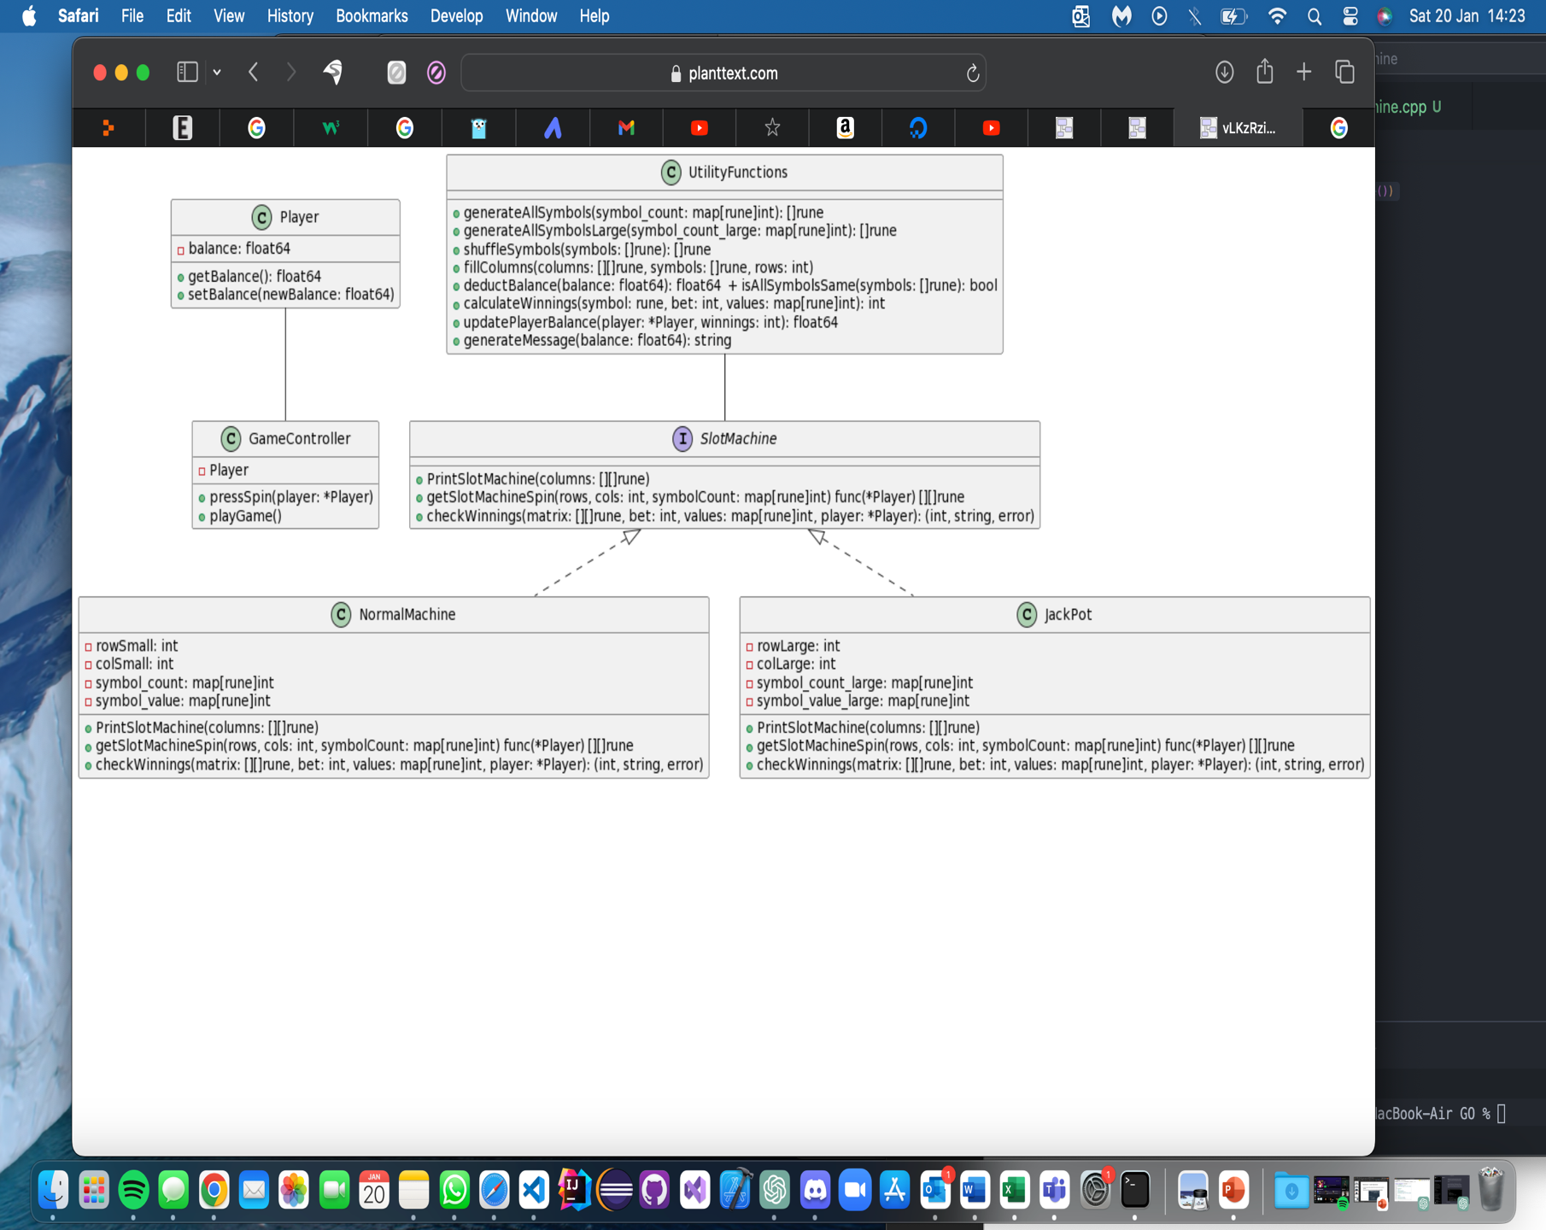

**Pseudo Code:**

**Create Player Struct:**

- Define the `Player` struct in the `main` package with a field `balance` of type `float64`.

- Implement the `NewPlayer` function, which initializes a new player with a default balance of 10.0.

- Implement the `getBalance` and `setBalance` functions for accessing and updating the player's balance.

**Create Main Function:**

- In the `main` function, create an instance of `GameController` by calling `NewPlayer` and embedding the resulting `Player` instance.

- Call the `playGame` function on the `GameController` instance to start the game.

**Create Interface SlotMachine:**

**-** Define the `SlotMachine` interface within the `main` package.

- Declare functions `PrintSlotMachine`, `getSlotMachineSpin`, and `checkWinnings` without providing implementations.

**Implement NormalMachine and JackPotMachine:**

- Define `NormalMachine` and `JackPot` types within the `main` package.

- Implement the `SlotMachine` interface for both types by providing specific implementations for each function.

**Create GameController Class:**

- Define the `GameController` struct within the `main` package, embedding the `Player` struct.

- Implement the `pressSpin` function, which simulates a single spin on the slot machine, deducts the bet amount from the player's balance, and prints the result.

- Implement the `playGame` function, which allows the player to continuously spin the machine until they choose to quit, showing the balance at the end.

**Refactor SlotMachine Functions:**

- Refactor the `SlotMachine` functions in `NormalMachine` and `JackPot` to match the interface, ensuring that the function signatures and logic adhere to the specified requirements.

**Development Process :**

I followed the same structure of the C++ OOP paradigm initially. As this allowed me to use the methods as a starting point for the whole code implementation. Whilst they will not be initially particularly functional, having a working product and being be able to implement more functional features such as editing the method or combine methods after seems as a more efficient approach. Photos will be at a minimum until more functional features are starting to be developed off the other paradigm features.

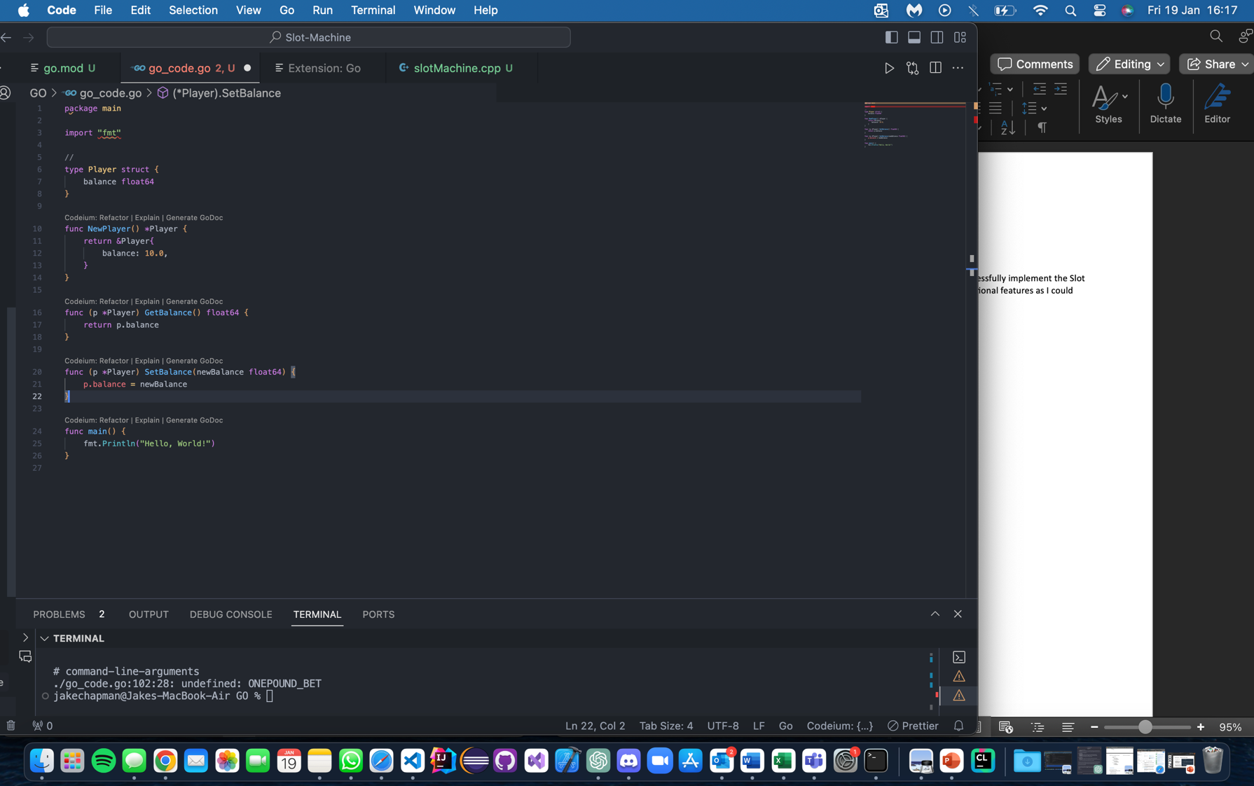

Like before instead of representing the slot machine as a class the **SlotMachine** as a interface and define functions that operate on that data structure. Like what I had done previously.

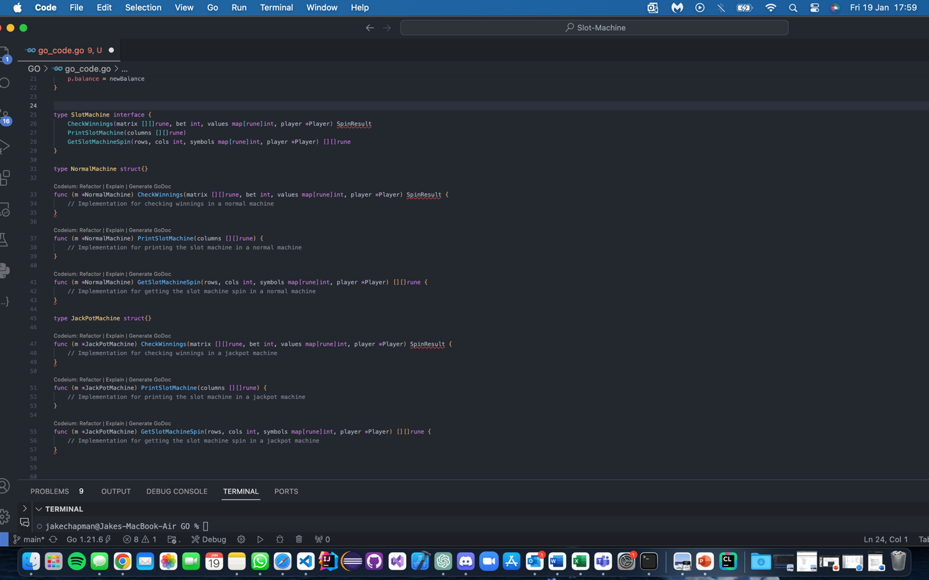

Initially, I tested the `PrintSlotMachine` method to ensure the correct generation of slot machine borders. Subsequently, I extended the evaluation to the `JackPotMachine` by introducing new constants, confirming its accurate functionality in printing as well.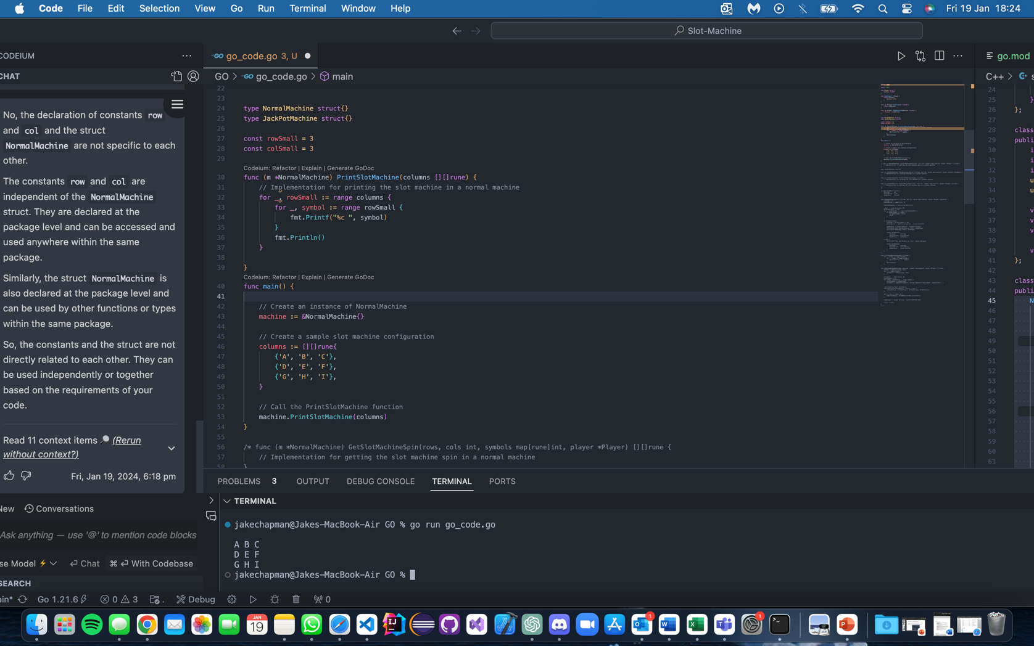

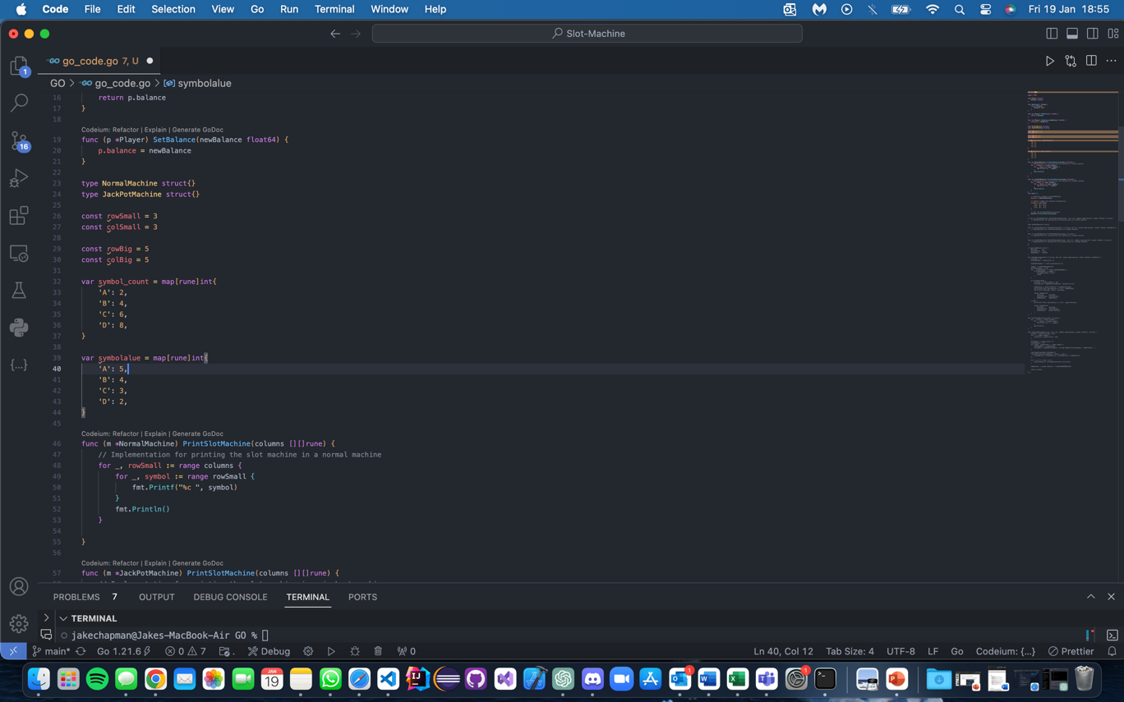

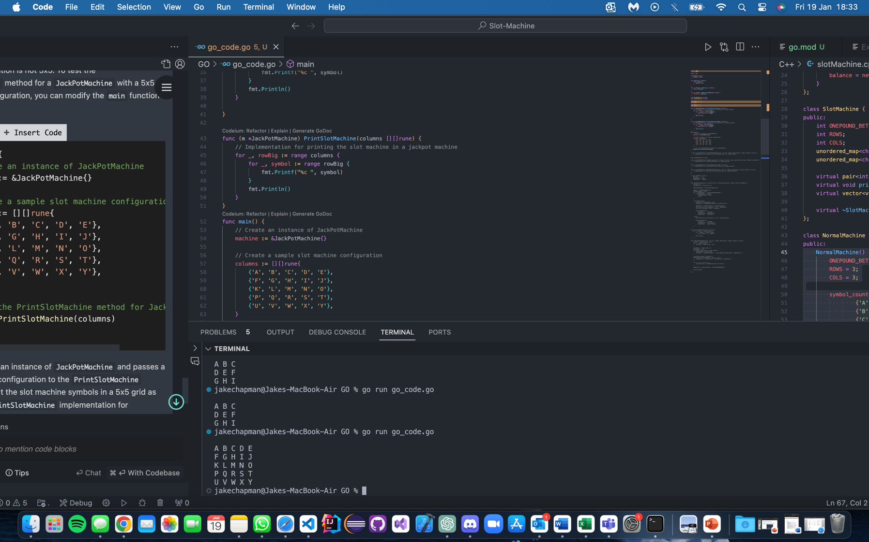

Develop the Normal Rune/Map for the get_slot_machine_spin method.

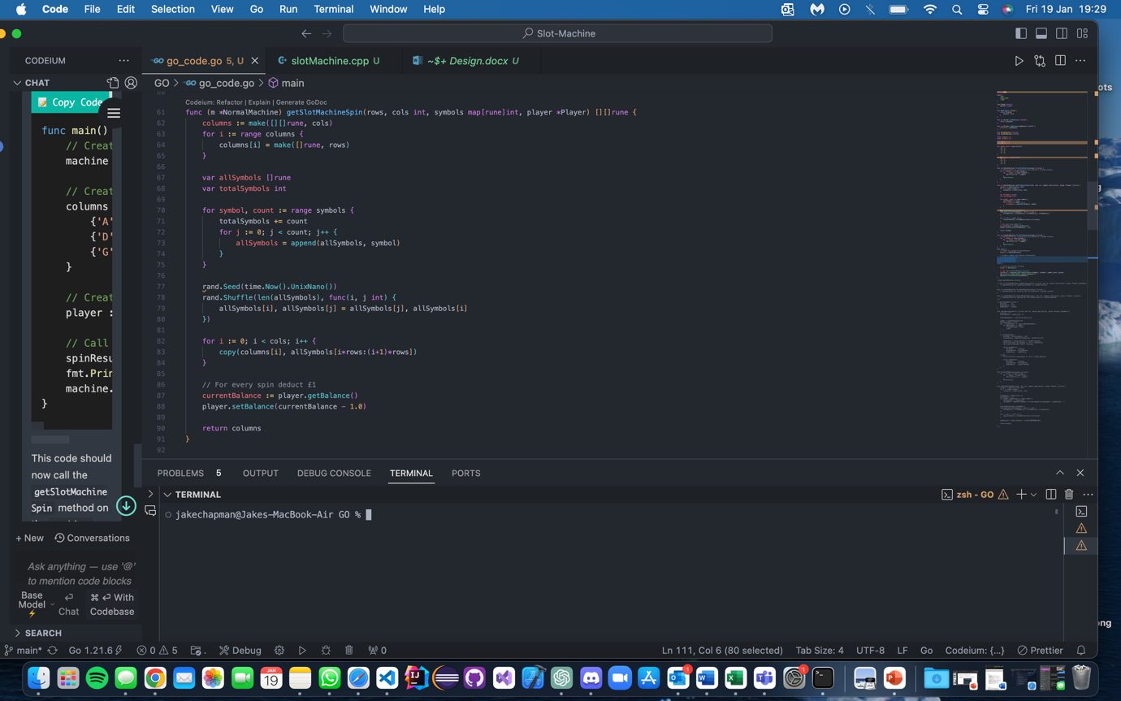

Spin is randomised every time as it should function minimising the players balance by £1. JackPot will almost identical implementation.

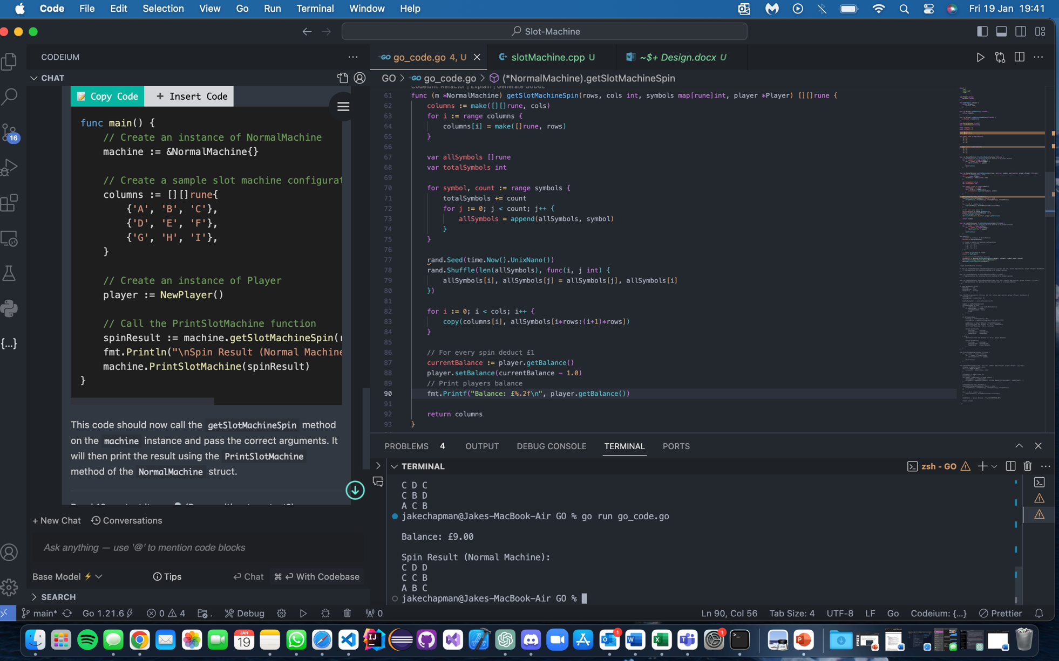

Now that it was working it was time to consider how we could make the program more functional. In this I asked ChatGPT what the main fundamentals of Functional programming are, to help aid in editing my programme to be a fully comprehensive functional paradigm slot machine. Here it was.

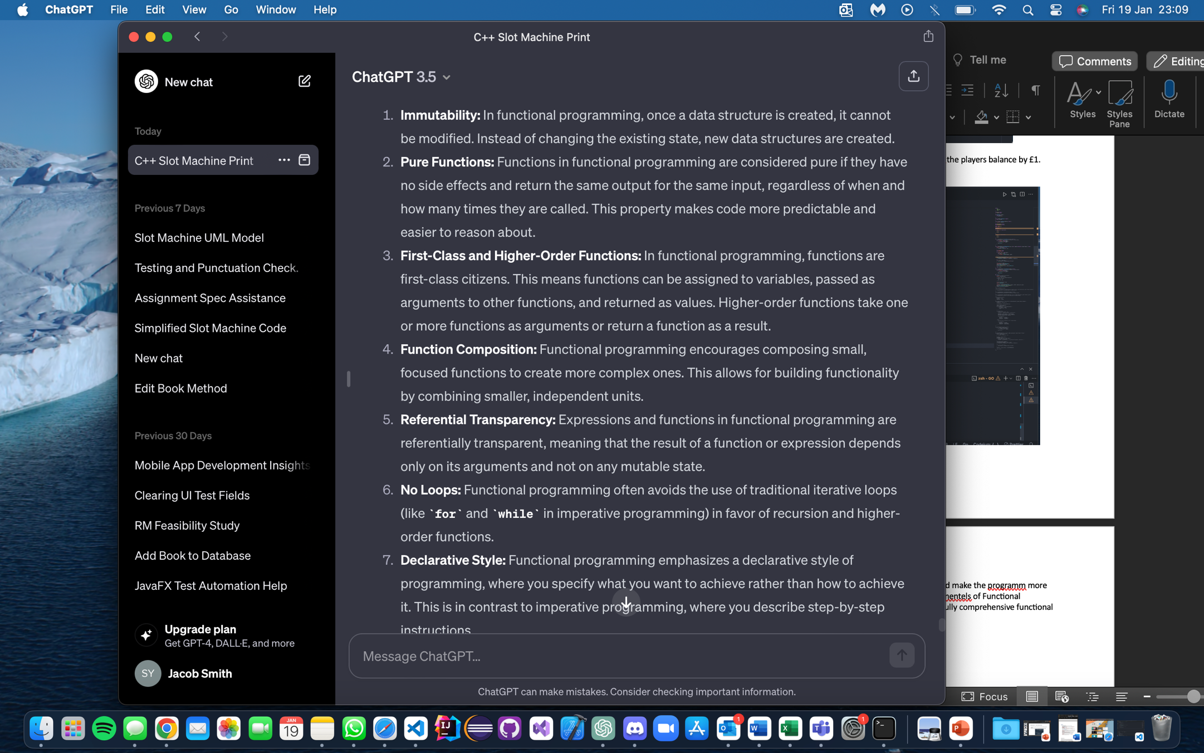

From these I decide to edit some of my function into smaller functions to more pure functions.

Here I am editing the check winnings method.

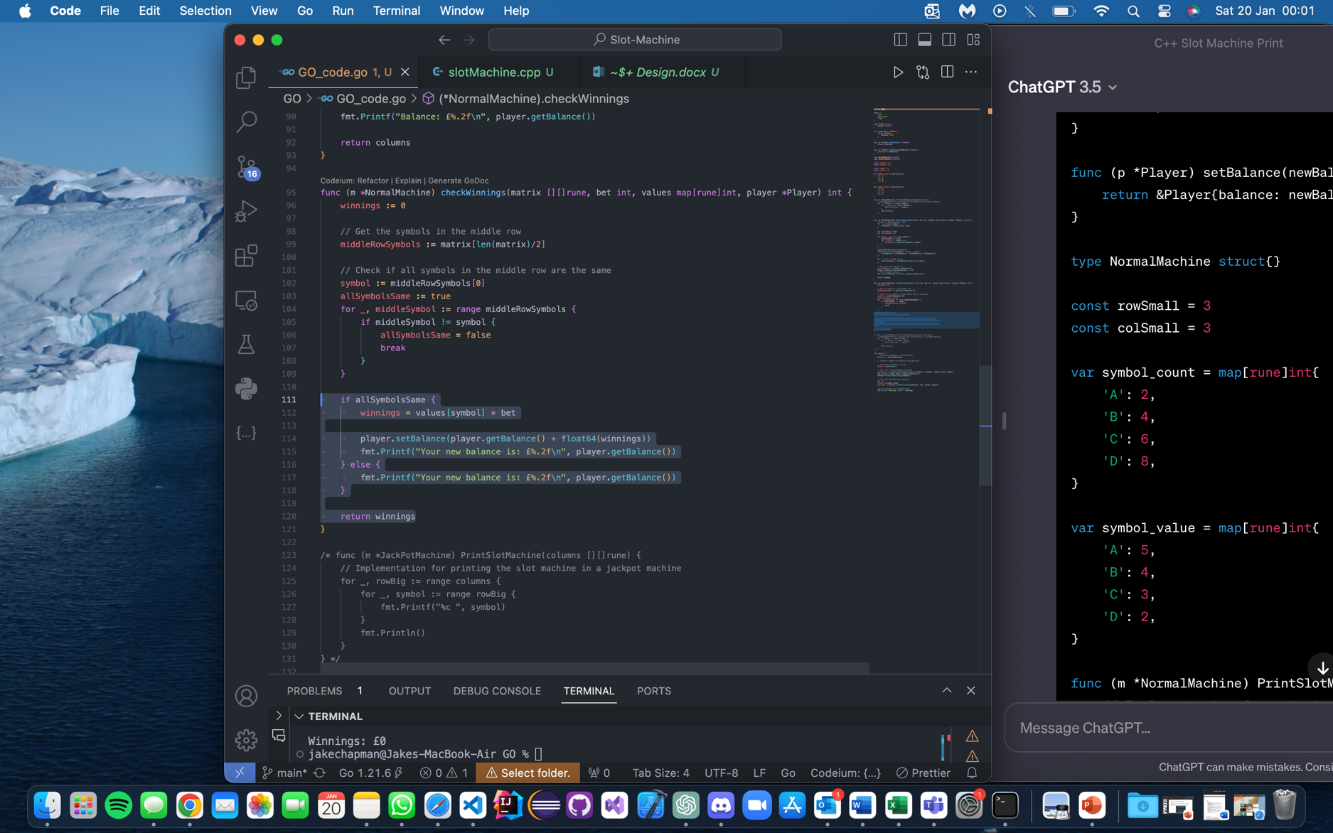

This change separates the logic of calculating the winnings function more functional.

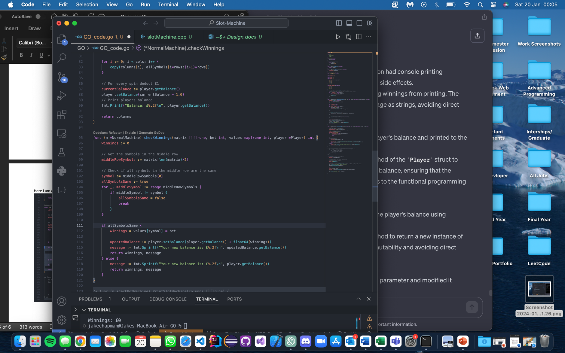

Here was my original balance methods and player methods.

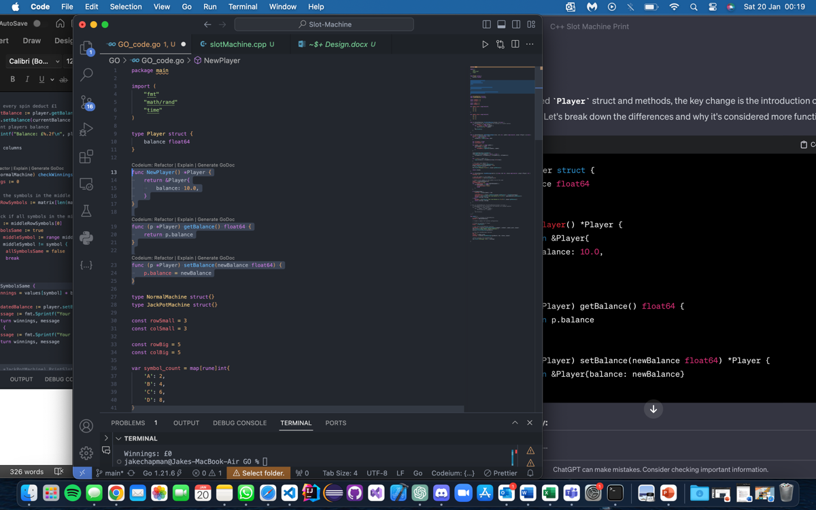

Now in this modified the setBalance doesn’t modify the existing Player it now creates a new one with updated balance. This ensure the original player is unchanged promoting immutability.

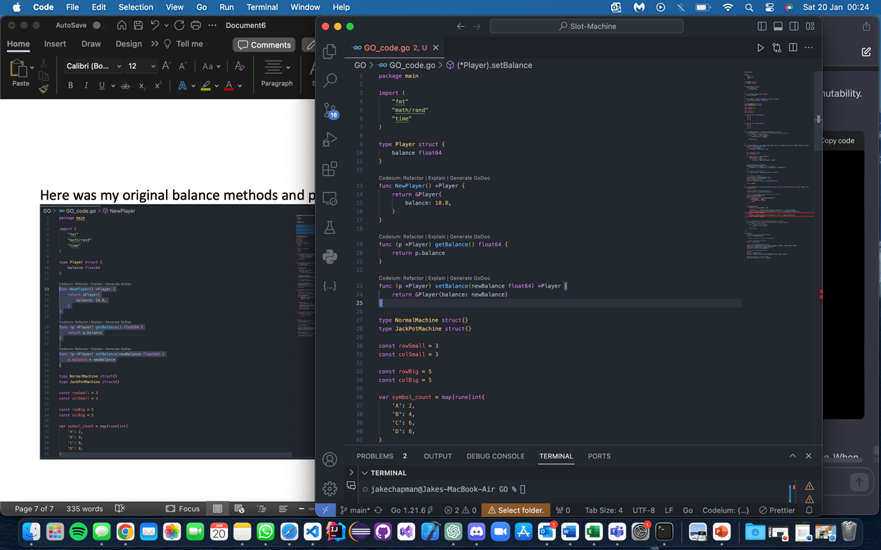

However this did not prove to enhance the code function despite it promoting use of functional paradigm, a new player being object being created does not make sense as they always have a new balance after every time they spin.

Another bug I came across was not being able to break out of a loop when the use would enter n to not play again as shown.

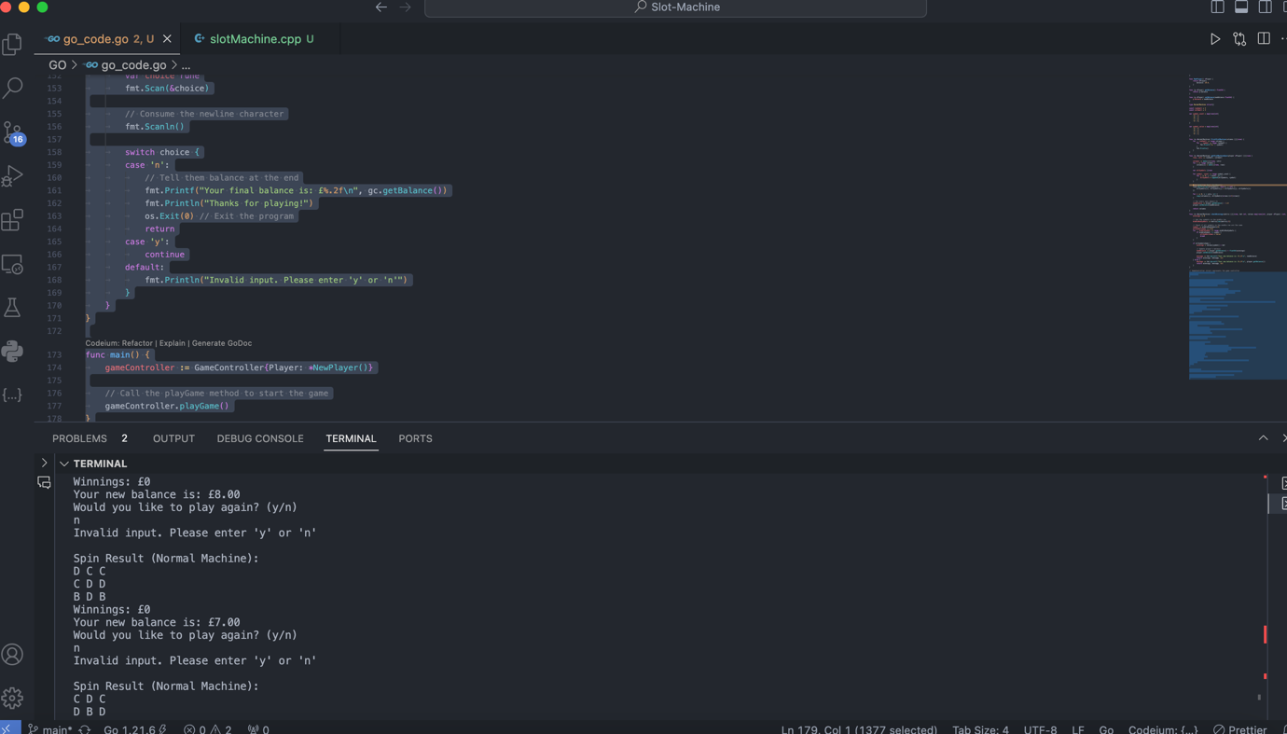

To fix the issue I changed var choice rune to var choice string to capture the newline character.

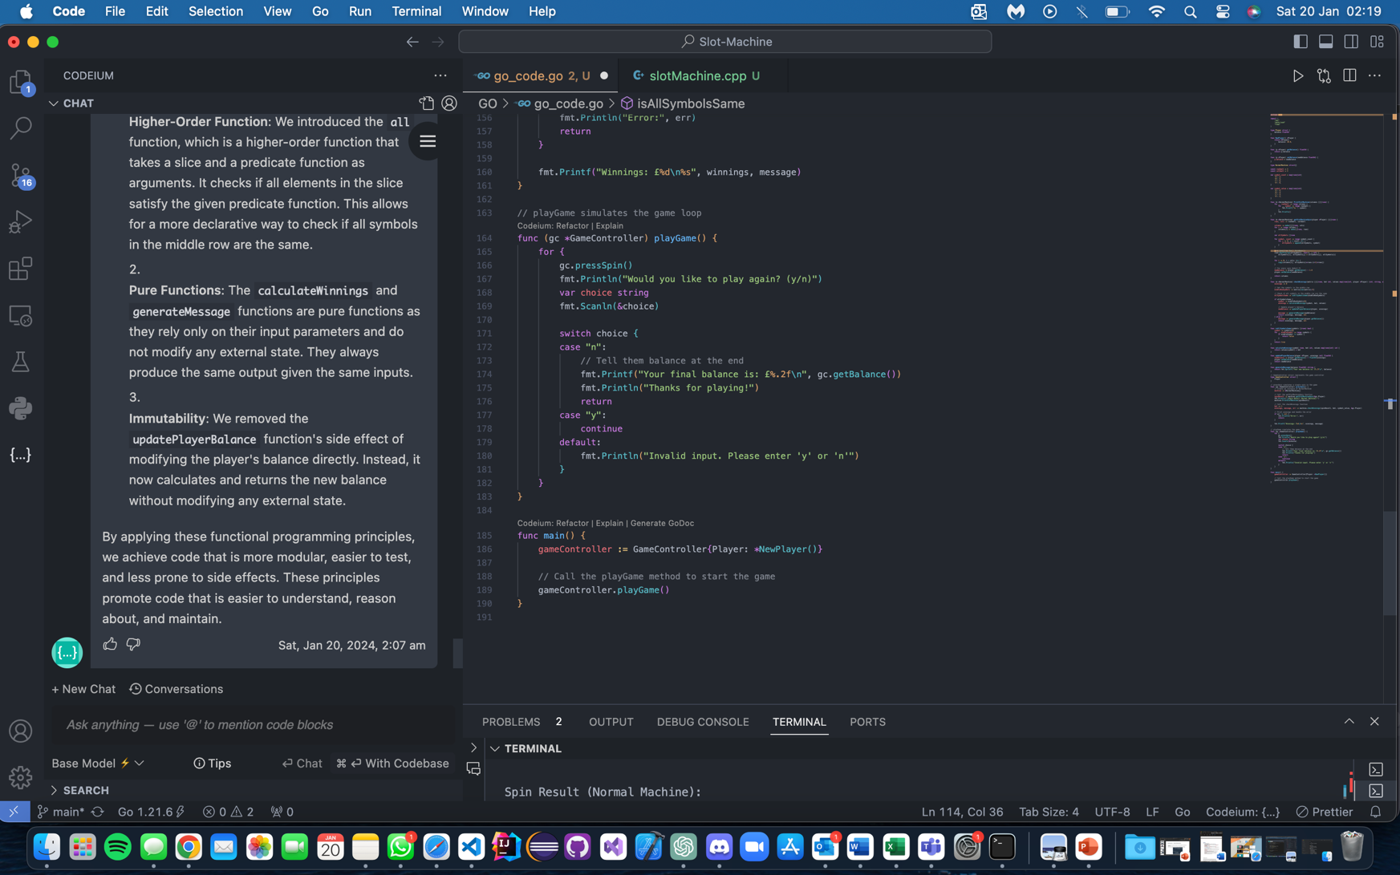

I was struggling to edit some of the working code to make it more code more functional so I asked Codium if it could make check winnings function more functional as an example/guidance.

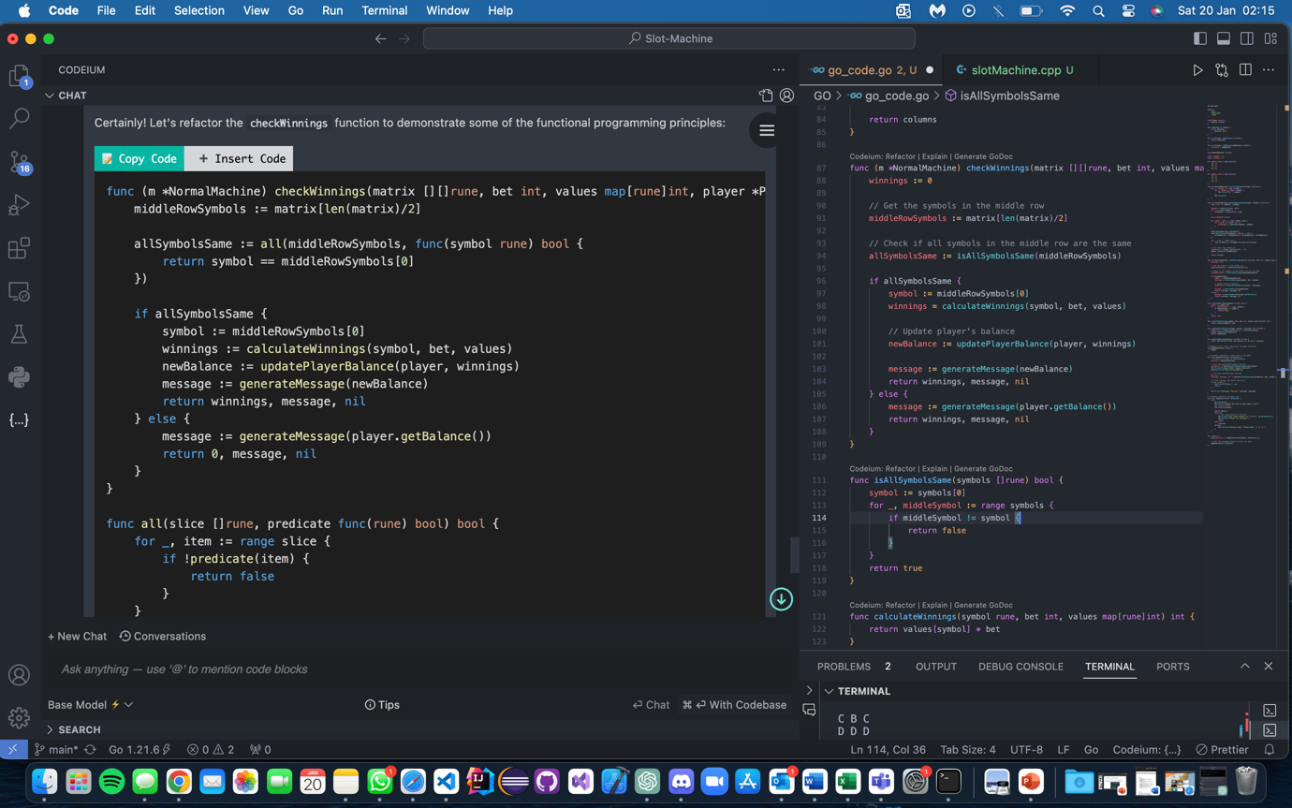

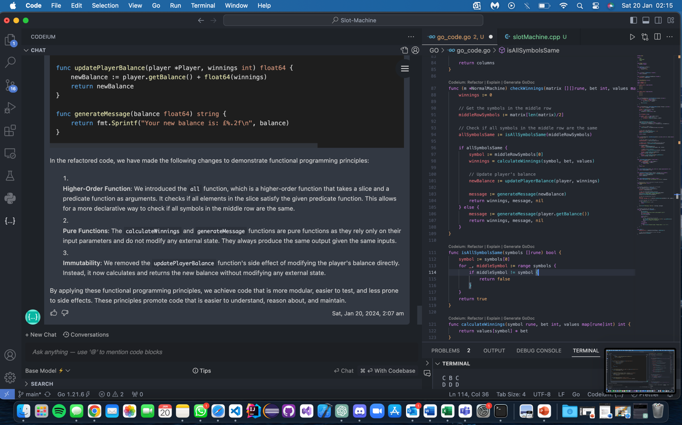

These interactions with Codium proved successful and were easily validated, as the code continued to run in the correct manner. Whilst also adding more features which adhere to the paradigm.

So, I then decide to apply the same features to the get_slot_machine function, here is the original.

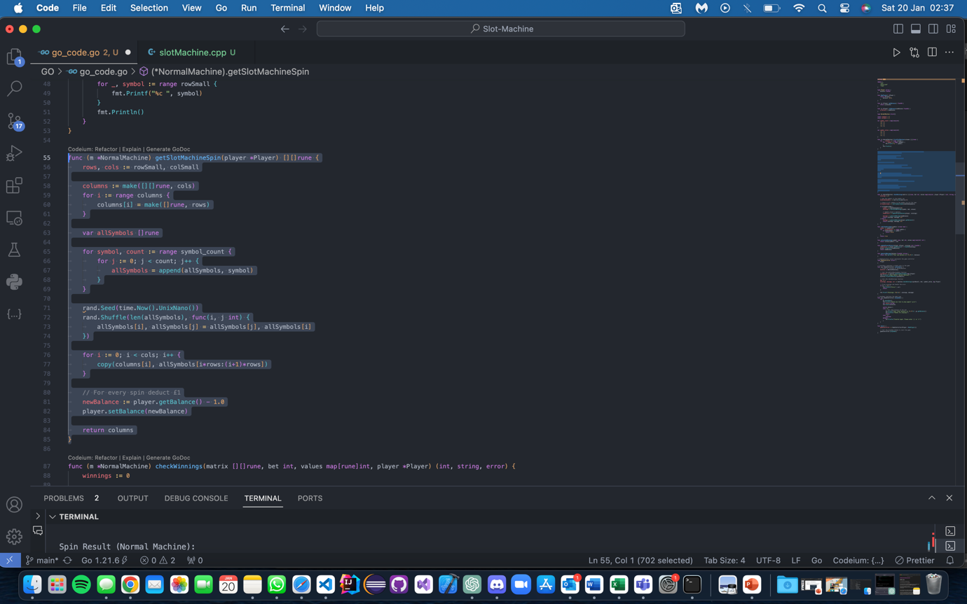

Here were the changes I made. I went off the suggestions of what codium said by creating but instead applied it to get_slot machine .

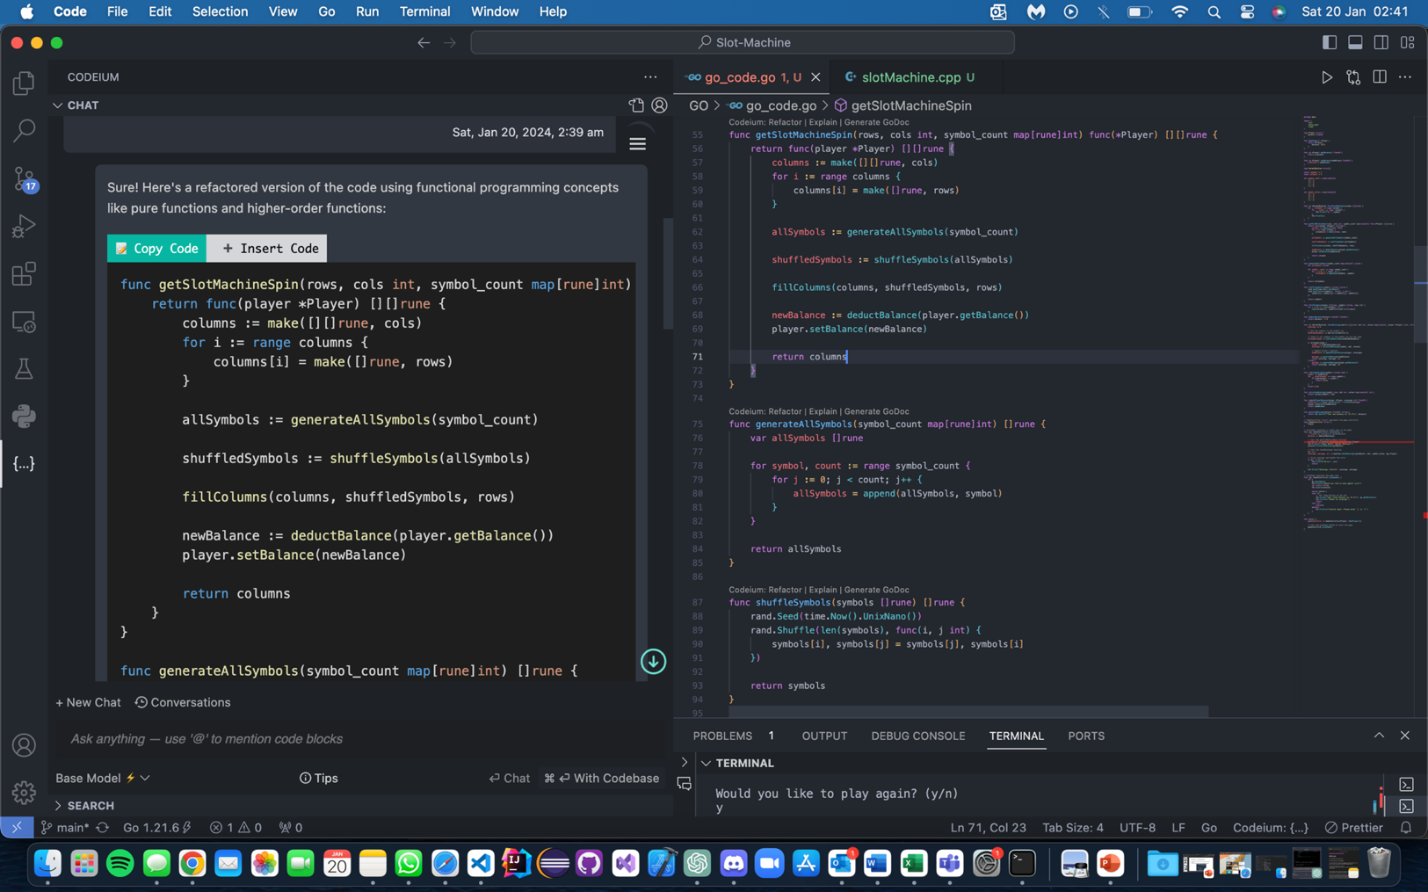

After this I changed playGame and pressSpin to account for these changes. After this I implemented the jackPot machine methods which were just a variation of the Normal machine methods just accounting for the symbol change and grid change.

To account for function pressSpin in which it would switch from jackPot to Normal I had to implement a Interface of SlotMachine . Otherwise I would get errors ‘m’ is not declared . This was easily implemeted in the rest of the code and in the pressSpin method by simply with ‘var m SlotMachine’

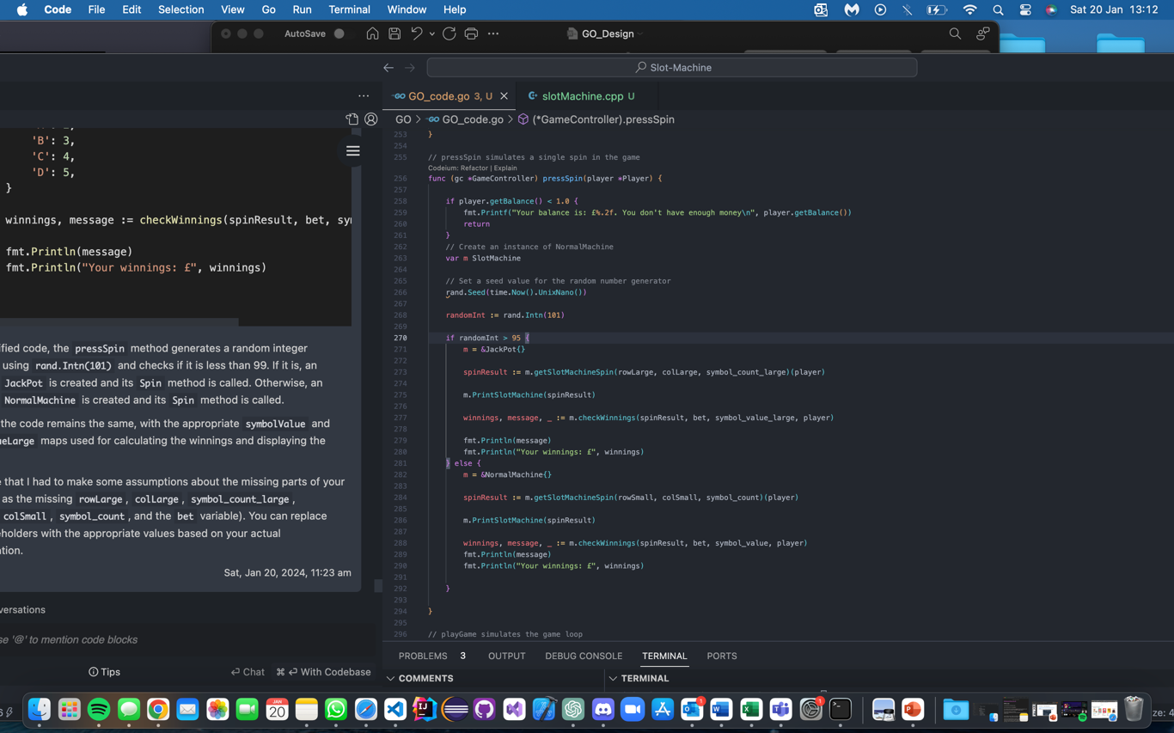

After this the code officially worked correctly acting as it should.